Esther T. Thyssen

**Pavia, Philip (1912-2005) Word Count: 505**

American sculptor and organiser of the New York art community, Philip Pavia sought to forge a group identity for the New York School. Pavia founded the Downtown Artists Club (1949-1955) with Willem de Kooning, Franz Kline, Ibram Lassaw and others. "The Club" transformed earlier gatherings into an intellectual and social forum as artists debated propositions and principles of Abstract Expressionism as well as the moniker itself. Lectures by luminaries like Joseph Campbell, John Cage and Hannah Arendt, and bi-weekly discussions nurtured artists' theories. Harold Rosenberg's milestone essay "The American Action Painters" (1952), for example, evolved from club panels convened by Pavia on "problems" of Abstract Expressionism. Dislike of French Surrealist influence, and challenge to the validity of formalist arguments were common. Pavia initiated annual exhibitions with the *Ninth Street Show* in 1951. Between 1958 and 1965, as an extension of the annuals, Pavia edited and published the periodical *It is. a magazine for abstract art* (sic). Critical writing, manifestoes and statements by fellow artists were printed alongside reproductions of new work. The periodical was structured as an artists' archive for Abstract Expressionism during the mature phase of the movement. Concurrently Pavia made abstract sculpture in bronze, stone, and clay.

Pavia was born the son of a stonecutter in Bridgeport, Connecticut and received sculpture training for the building trades in his youth. He then pursued fine arts study at the Arts Students League of New York and met Raoul Hague, Ibram Lassaw, Arshile Gorky and Jackson Pollock in the 1930s. After 1934 he studied sculpture in Florence at the Accademia delle Belle Arti, and attended classes at Atelier Bonnet in Paris. Conversations with the American expatriate writer Henry Miller, along with encounters Picasso's work ignited his interest in practices of the avant-garde. In New York Pavia ran and documented activities at The Club and pursued his own sculptural work. In his sculpture Pavia explored Abstract Expressionist approaches, chose materials for indexical content, and allowed the qualities of process to rouse his subjects. His sculptural oeuvre exudes the late modernist tenet that meaning resides within all attributes of the work including processes of its making. He secured emerging meaning with evocative titles like *Connecticut River* (1959), and *African Nightfall* (1965). During the 1960s Pavia cut marble directly, leaning and stacking slabs to evoke chance effects. Pavia's abstract assemblages reference the quarrying and carving processes, as well as the force of gravity relevant for stone. Irregular shapes occasionally transmogrify into smoothly finished geometric segments as distinction between natural, organic growth, and human action disappears. Pavia's work hovers between abstract and metaphorical emphases even in his bronze portraits of the 1970s. For his final series he modeled colossal heads in clay (2002-2005).

**References and further reading**

Edgar, N. (ed) (2007) Club Without Walls: Selections from the Journals of Philip Pavia, New York: Midmarch Arts Press

Gibson, A. E. (2005) "It is. A magazine for abstract art." New York School: Another View (exh. cat.) Albany, NY: Opalka Gallery

Nordland, G. (1966) Phillip [sic] Pavia. (exh. cat.) Washington, DC: Washington, D.C. Gallery of Modern Art

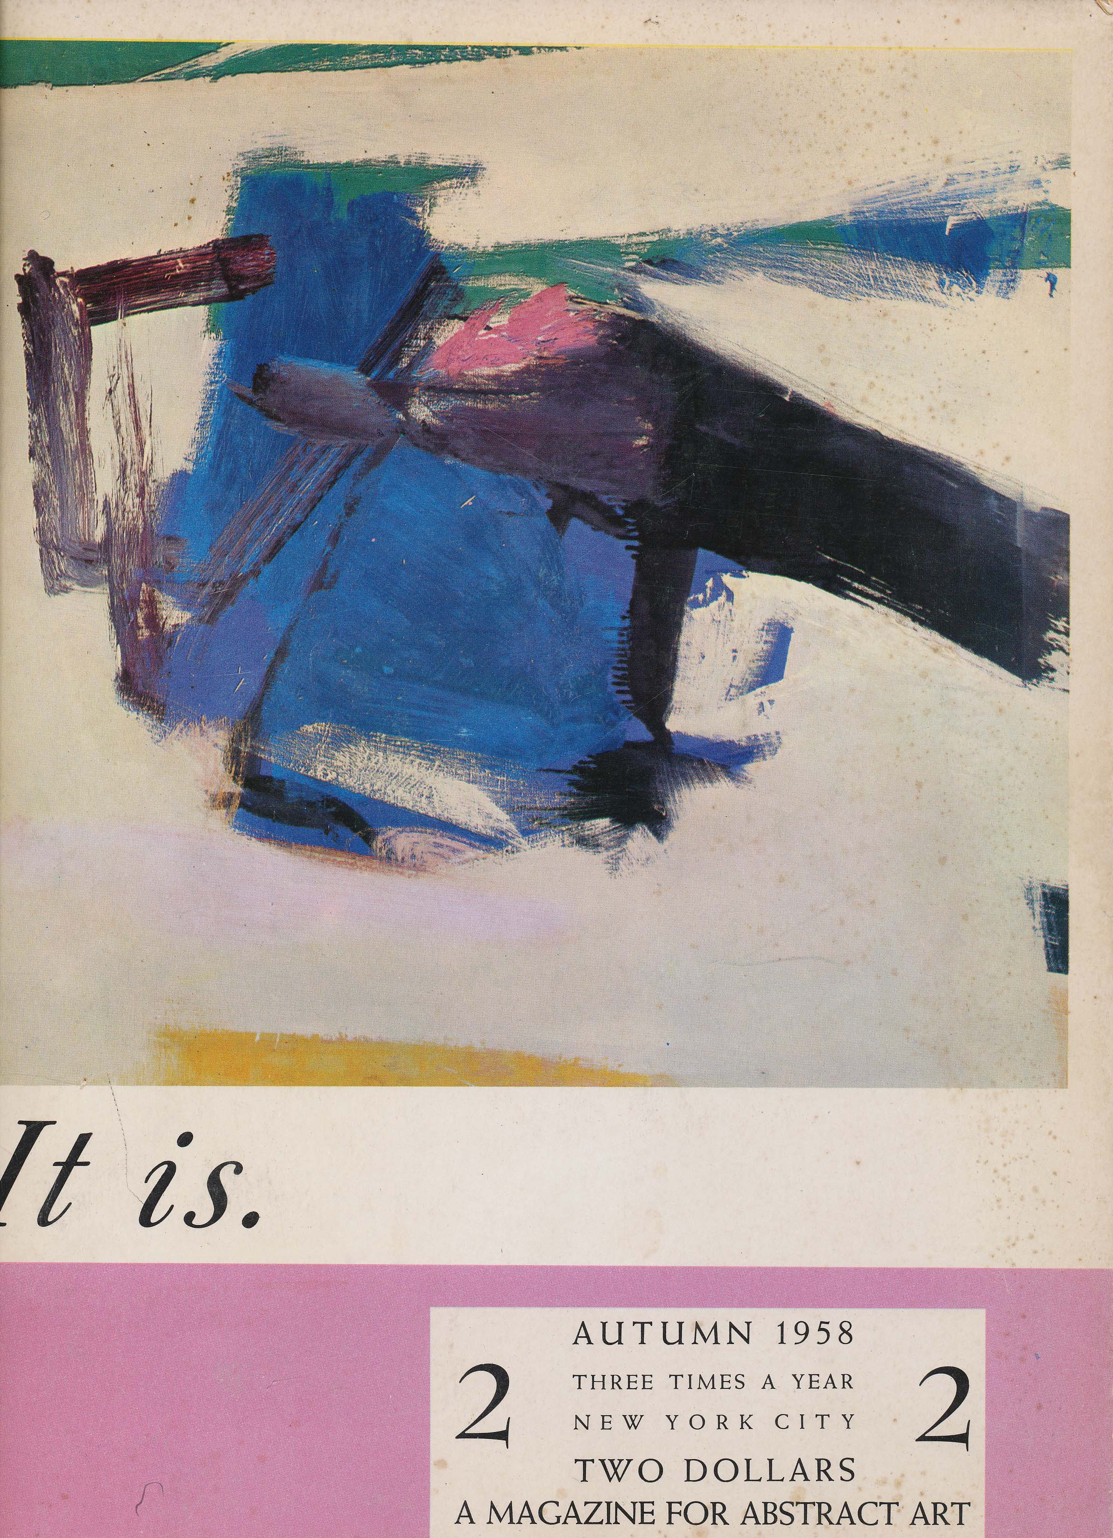

<http://findingaids.library.emory.edu/documents/pavia981/>

<http://www.abartonline.com/html/ac1_1.html>